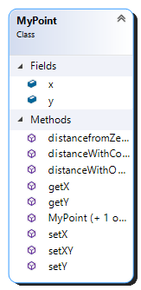DOMAIN MODEL WITH MULTIPLICITY

HAS

1

∞